# ASP .NET实验报告01

## **实验一:(可以直接访问<http://bingqiangzhou.cn:8080/Exp0101/> 查看效果)**

### （1）实验内容

创建一个静态网站，网站内容自行设计，如个人博客（介绍自己的基本信息或者自己的兴趣爱好等）或班级网站等。网页中必须用到以下技术：

1. 使用不同字体、颜色的文本；使用背景图片；
2. 使用两种列表之一；
3. 使用各类超链接（文本超链接/锚点超链接等）；
4. 使用CSS进行页面美化；
5. 使用Div/CSS进行页面布局，如将页面划分成3行,中间行分成2列。

### （2）程序源码

#### （2.1）Index.html

<!doctype html>

<html>

<head>

<meta charset="utf-8">

<meta http-equiv="X-UA-Compatible" content="IE=edge">

<meta name="viewport" content="width=device-width, initial-scale=1.0">

<title>Programming Language</title>

<link href="css/bootstrap-4.0.0.css" rel="stylesheet" type="text/css">

<link href="index.css" rel="stylesheet" type="text/css">

<script src="js/jquery-3.2.1.min.js"></script>

<script src="js/popper.min.js"></script>

<script src="js/bootstrap-4.0.0.js"></script>

</head>

<body style="padding-top: 70px; padding-bottom: 70px;">

<nav class="navbar fixed-top navbar-expand-lg navbar-light bg-light">

<div class="container">

<a class="navbar-brand" href="#">Welcome</a>

<button class="navbar-toggler" type="button" data-toggle="collapse" data-target="#navbarSupportedContent1" aria-controls="navbarSupportedContent1" aria-expanded="false" aria-label="Toggle navigation"> <span class="navbar-toggler-icon"></span> </button>

<div class="collapse navbar-collapse" id="navbarSupportedContent1">

<ul class="navbar-nav mr-auto">

<li class="nav-item active"> <a class="nav-link" href="#">Home <span class="sr-only">(current)</span></a> </li>

<li class="nav-item"> <a class="nav-link" target="_blank" href="https://www.tiobe.com/tiobe-index/">TIOBE</a> </li>

<li class="nav-item dropdown"> <a class="nav-link dropdown-toggle" href="#" id="navbarDropdown1" role="button" data-toggle="dropdown" aria-haspopup="true" aria-expanded="false"> Programming Language </a>

<div class="dropdown-menu" aria-labelledby="navbarDropdown1">

<a class="dropdown-header" href="#">Top Six</a>

<div class="dropdown-divider"></div>

<a class="dropdown-item" href="#c">C</a>

<a class="dropdown-item" href="#java">Java</a>

<a class="dropdown-item" href="#python">Python</a>

<a class="dropdown-item" href="#cplusplus">C++</a>

<a class="dropdown-item" href="#vb">Visual Basic .NET</a>

<a class="dropdown-item" href="#csharp">C#</a>

</div>

</li>

</ul>

</div>

</div>

</nav>

<div class="content">

<div class="row justify-content-md-center">

<div class="card col-md-5"> <img class="card-img-top" src="images/c.png" alt="Card image cap">

<div class="card-body">

<h5 class="card-title">C</h5>

<p class="card-text">C is a general-purpose, imperative computer programming language, supporting structured programming, lexical variable scope and recursion, while a static type system prevents many unintended operations. </p>

<a target="_blank" href="https://en.wikipedia.org/wiki/C_(programming_language)" class="btn btn-primary">Learn More</a> </div>

</div>

<div class="card col-md-5" id="java"> <img class="card-img-top" src="images/java.png" alt="Card image cap">

<div class="card-body">

<h5 class="card-title">Java</h5>

<p class="card-text">Java is a general-purpose computer-programming language that is concurrent, class-based, object-oriented,and specifically designed to have as few implementation dependencies as possible. </p>

<a target="_blank" href="https://en.wikipedia.org/wiki/Java_(programming_language)" class="btn btn-primary">Learn More</a> </div>

</div>

</div>

<div class="row justify-content-md-center">

<div class="card col-md-5" id="python"> <img class="card-img-top" src="images/python.png" alt="Card image cap">

<div class="card-body">

<h5 class="card-title">Python</h5>

<p class="card-text">Python is an interpreted high-level programming language for general-purpose programming. Created by Guido van Rossum and first released in 1991, Python has a design philosophy that emphasizes code readability, </p>

<a target="_blank" href="https://en.wikipedia.org/wiki/Python_(programming_language)" class="btn btn-primary">Learn More</a> </div>

</div>

<div class="card col-md-5" id="cplusplus"> <img class="card-img-top" src="images/cplusplus.png" alt="Card image cap">

<div class="card-body">

<h5 class="card-title">C++</h5>

<p class="card-text">C++ is a general-purpose programming language. It has imperative, object-oriented and generic programming features, while also providing facilities for low-level memory manipulation.</p>

<a target="_blank" href="https://en.wikipedia.org/wiki/C%2B%2B" class="btn btn-primary">Learn More</a> </div>

</div>

</div>

<div class="row justify-content-md-center">

<div class="card col-md-5" id="vb"> <img class="card-img-top content-img" src="images/vb.png" alt="Card image cap">

<div class="card-body">

<h5 class="card-title">Visual Basic .NET</h5>

<p class="card-text">Visual Basic .NET (VB.NET) is a multi-paradigm, object-oriented programming language, implemented on the .NET Framework. Microsoft launched VB.NET in 2002 as the successor to its original Visual Basic language. </p>

<a target="_blank" href="https://en.wikipedia.org/wiki/Visual_Basic_.NET" class="btn btn-primary">Learn More</a> </div>

</div>

<div class="card col-md-5" id="csharp"> <img class="card-img-top" src="images/csharp.png" alt="Card image cap">

<div class="card-body">

<h5 class="card-title">C#</h5>

<p class="card-text">C# is a multi-paradigm programming language encompassing strong typing, imperative, declarative, functional, generic, object-oriented (class-based), and component-oriented programming disciplines.</p>

<a target="_blank" href="https://en.wikipedia.org/wiki/C_Sharp_(programming_language)" class="btn btn-primary">Learn More</a> </div>

</div>

</div>

<footer class="bg-light" id="copyright">

<div class="container">

<p><font face="KaiTi">&copy; 2018</font> - <font face="FangSong">Bingqiang Zhou</font></p>

</div>

</footer>

</body>

</html>

#### （2.2）Index.css

/* CSS Document */

body{

padding: 0px;

margin: 0px;

background-image: url(images/bg.jpg);

}

.row{

margin-top: 1%;

}

### （3）效果截图

#### （3.1）使用不同字体、颜色的文本；使用背景图片

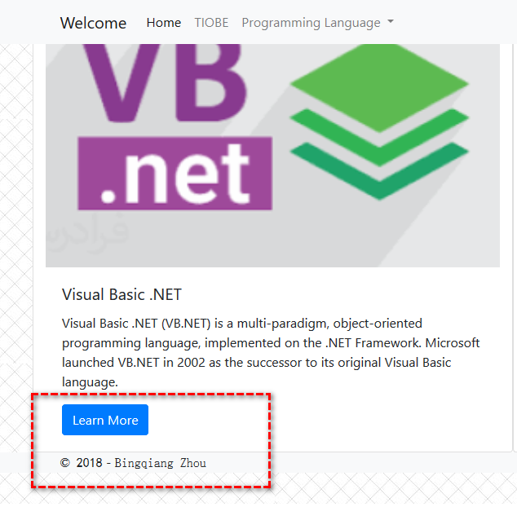

图1、使用不同字体、颜色的文本；使用背景图片

#### （3.2）使用两种列表之一

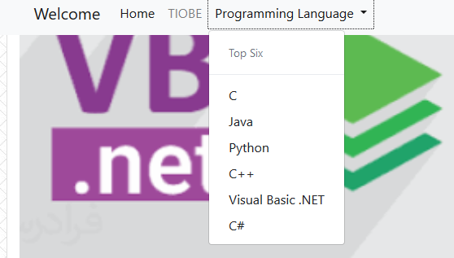

图2、使用两种列表之一

#### （3.3）使用各类超链接（文本超链接/锚点超链接等）

如图1、图2所示：图1中learn more为文本超链接，图2中列表项为锚点超链接

#### （3.4）使用CSS进行页面美化

使用bootstrap框架美化页面

#### （3.5）使用Div/CSS进行页面布局，如将页面划分成3行,中间行分成2列

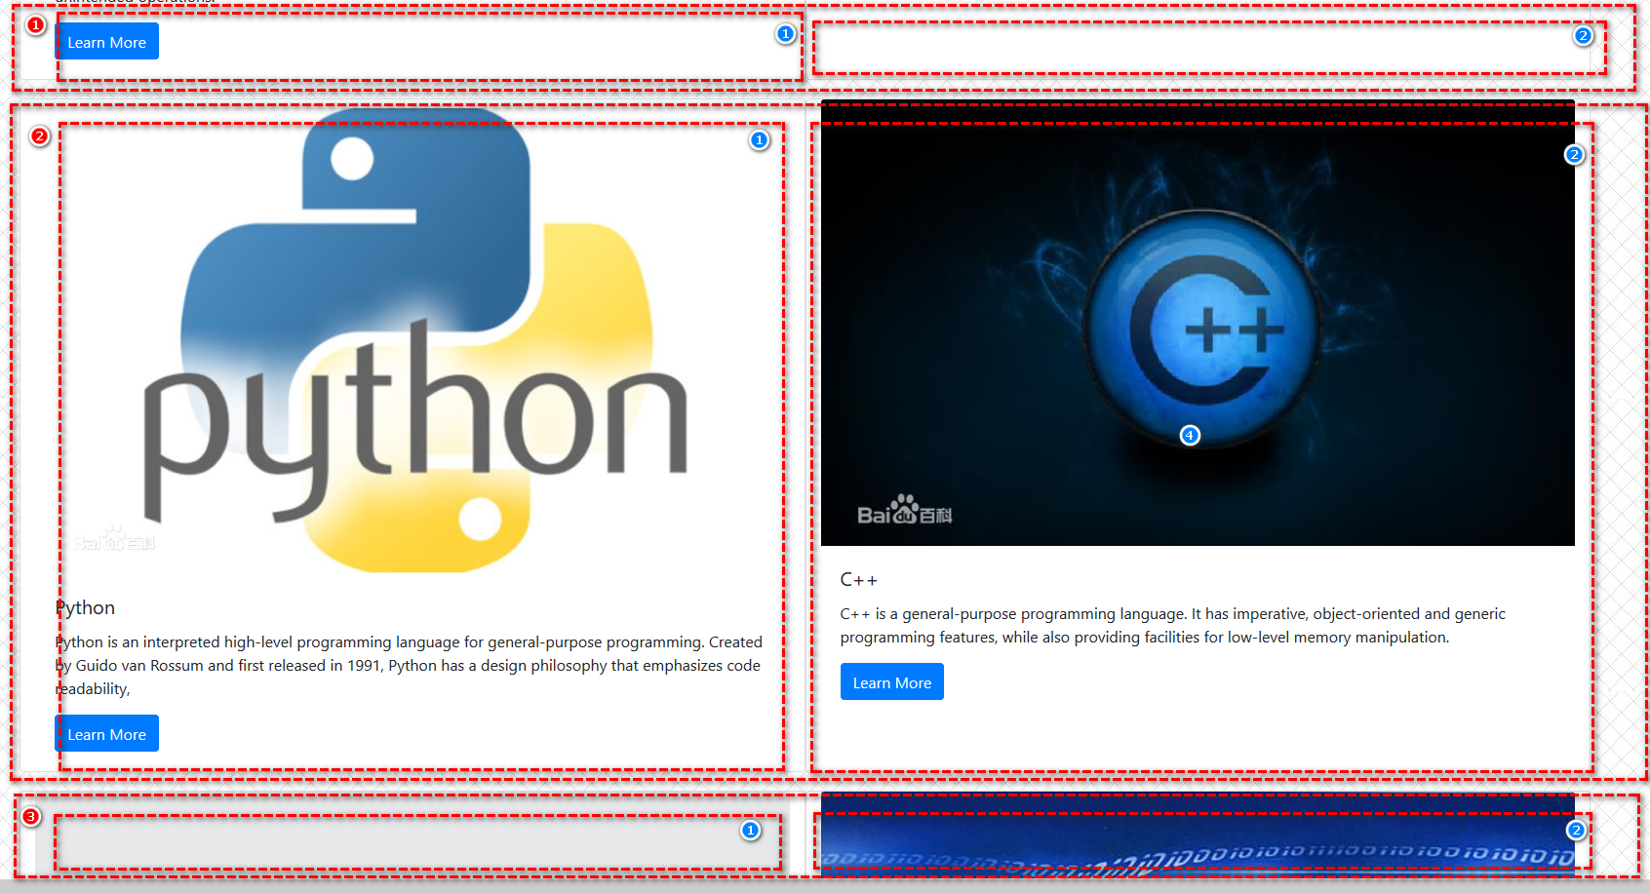

图3、使用Div/CSS进行页面布局，如将页面划分成3行,中间行分成2列。

## **实验二:(可以直接访问<http://bingqiangzhou.cn:8080/Exp0102/> 查看效果)**

### （1）实验内容

创建多张网页，并实现网页之间多种方法的转移。转移方法包括：

1. 利用HyperLink控件
2. 利用Response.Redirect()方法。
3. 在ImageMap上放置一个热点，并实现对其它页面的超链接。

### （2）实验源码

#### （2.1）Default.aspx

<%@ Page Language="C#" %>

<!DOCTYPE html>

<script runat="server">

/// <summary>

/// 利用Response.Redirect()方法。

/// </summary>

/// <param name="sender"></param>

/// <param name="e"></param>

protected void redirectButton_Click(object sender, EventArgs e)

{

Response.Redirect("website01.aspx");

}

</script>

<html lang="en" xmlns="http://www.w3.org/1999/xhtml">

<head runat="server">

<meta charset="utf-8" />

<title></title>

<link rel="stylesheet" href="Content/bootstrap.css" />

<script src="Scripts/bootstrap.min.js"></script>

</head>

<body>

<nav class="navbar navbar-drak bg-light">

<div class="container">

<%--利用HyperLink控件--%>

<asp:HyperLink ID="website01" CssClass="navbar-brand"

NavigateUrl="~/website01.aspx" runat="server">first website</asp:HyperLink>

<%--利用Response.Redirect()方法。--%>

<div class="navbar-nav">

<form class="form-inline" runat="server">

<asp:Button ID="redirectButton" CssClass="btn btn-outline-secondary" runat="server" Text="redirect to website01" onclick="redirectButton_Click" />

</form>

</div>

</div>

</nav>

</body>

</html>

#### （2.2）website01.aspx

<%@ Page Language="C#" AutoEventWireup="true" CodeBehind="website01.aspx.cs" Inherits="WebApplication1.website01" %>

<!DOCTYPE html>

<html xmlns="http://www.w3.org/1999/xhtml">

<head runat="server">

<title></title>

<style>

body{margin:auto;width:1000px;text-align:center;}

</style>

</head>

<body>

<%--利用HyperLink控件--%>

<asp:HyperLink ID="Default" NavigateUrl="~/Default.aspx" runat="server">Home Page</asp:HyperLink>

<%--在ImageMap上放置一个热点，并实现对其它页面的超链接。--%>

<asp:ImageMap ID="ImageMap1" ImageUrl="icon.jpg" runat="server">

<asp:RectangleHotSpot HotSpotMode="Navigate" NavigateUrl="http://bingqiangzhou.cn:8080/Exp0101" AlternateText="To Homepage"

Top="0" Left="0" Bottom="300" Right="300" />

<asp:RectangleHotSpot HotSpotMode="Navigate" NavigateUrl="http://bingqiangzhou.cn:8080/Exp0103" AlternateText="To Homepage"

Top="0" Left="300" Bottom="300" Right="590" />

<asp:RectangleHotSpot HotSpotMode="Navigate" NavigateUrl="http://bingqiangzhou.cn:8080/Exp0104" AlternateText="To Homepage"

Top="300" Left="0" Bottom="590" Right="300" />

<asp:RectangleHotSpot HotSpotMode="Navigate" NavigateUrl="http://bingqiangzhou.cn:8080/Exp0105" AlternateText="To Homepage"

Top="300" Left="300" Bottom="590" Right="590" />

</asp:ImageMap>

</body>

</html>

### （3）效果截图

#### （3.1）利用HyperLink控件



图4、利用HyperLink控件

#### （3.2）利用Response.Redirect()方法



图5、利用Response.Redirect()方法

#### （3.3）在ImageMap上放置一个热点，并实现对其它页面的超链接。

图6、利用Response.Redirect()方法

## **实验三:(可以直接访问<http://bingqiangzhou.cn:8080/Exp0103/> 查看效果)**

### （1）实验内容

在第一个DropDownList中选中省份，在第二个DropDownList加载相应的城市。

### （2）实验源码

#### （2.1）Default.aspx

<%@ Page Language="C#" AutoEventWireup="true" CodeBehind="Default.aspx.cs" Inherits="WebApplication2._default" %>

<!DOCTYPE html>

<html xmlns="http://www.w3.org/1999/xhtml">

<head runat="server">

<title></title>

<style>

body{margin:auto;width:1000px;text-align:center;}

</style>

</head>

<body>

<form runat="server" style="margin:10%">

<asp:DropDownList ID="DropDownList1" runat="server" AutoPostBack="true" OnSelectedIndexChanged="DropDownList1_SelectedIndexChanged">

<asp:ListItem Selected="True" Value="0">please select province</asp:ListItem>

<asp:ListItem Value="1">Hunan</asp:ListItem>

<asp:ListItem Value="2">Shandong</asp:ListItem>

</asp:DropDownList>

<asp:DropDownList ID="DropDownList2" runat="server">

<asp:ListItem Selected="True" Value="0">please select city</asp:ListItem>

</asp:DropDownList>

<asp:Button ID="Submit" runat="server" OnClick="Submit_Click" Text="submit" />

</form>

</body>

</html>

#### （2.2）Default.aspx.cs

using System;

using System.Collections.Generic;

using System.Linq;

using System.Web;

using System.Web.UI;

using System.Web.UI.WebControls;

namespace WebApplication2

{

public partial class _default : System.Web.UI.Page

{

protected void Page_Load(object sender, EventArgs e)

{

}

protected void DropDownList1_SelectedIndexChanged(object sender, EventArgs e)

{

DropDownList2.Items.Clear();

switch (Convert.ToInt32(DropDownList1.SelectedValue))

{

case 1:

DropDownList2.Items.Add("ChangSha");

DropDownList2.Items.Add("ZhuZhou");

DropDownList2.Items.Add("XiangTan");

break;

case 2:

DropDownList2.Items.Add("QingDao");

DropDownList2.Items.Add("JiNan");

DropDownList2.Items.Add("YanTai");

break;

}

System.Diagnostics.Debug.WriteLine("Changed");//output debuging informations

}

protected void Submit_Click(object sender, EventArgs e)

{

Response.Write("you select "+DropDownList1.SelectedItem.Text+

" and " + DropDownList2.SelectedItem.Text);

}

}

}

### （3）效果截图

#### （3.1）在第一个DropDownList中选中省份，在第二个DropDownList加载相应的城市

图7、在第一个下拉框选中省份，在第二个下拉框加载相应的城市

## **实验四:(可以直接访问<http://bingqiangzhou.cn:8080/Exp0104/> 查看效果)**

### （1）实验内容

创建多个网页，在其中一个网页中输入姓名和密码，要求当转移到其它页面时，这个姓名和密码将自动显示到新的网页中。提示：使用Session。

### （2）实验源码

#### （2.1）Default.aspx

<%@ Page Language="C#" AutoEventWireup="true" CodeBehind="Default.aspx.cs" Inherits="WebApplication3.Default" %>

<!DOCTYPE html>

<html xmlns="http://www.w3.org/1999/xhtml">

<head runat="server">

<title></title>

<style>

body{margin:auto;width:1000px;text-align:center;}

</style>

</head>

<body>

<form id="form1" runat="server">

<p>Account</p>

<asp:TextBox ID="Account" runat="server"></asp:TextBox>

<p>Password</p>

<asp:TextBox ID="Password" TextMode="Password" runat="server"></asp:TextBox>

<p></p>

<asp:Button ID="Submit" runat="server" Text="Submit" OnClick="Submit_Click" />

</form>

</body>

</html>

#### （2.2）Default.aspx.cs

using System;

using System.Collections.Generic;

using System.Linq;

using System.Web;

using System.Web.UI;

using System.Web.UI.WebControls;

namespace WebApplication3

{

public partial class Default : System.Web.UI.Page

{

protected void Page_Load(object sender, EventArgs e)

{

}

protected void Submit_Click(object sender, EventArgs e)

{

Session["account"] = Account.Text;

Session["password"] = Password.Text;

Response.Redirect("info.aspx");

}

}

}

#### （2.3）Info.aspx

<%@ Page Language="C#" AutoEventWireup="true" CodeBehind="info.aspx.cs" Inherits="WebApplication3.info" %>

<!DOCTYPE html>

<html xmlns="http://www.w3.org/1999/xhtml">

<head runat="server">

<title></title>

<style>

body{margin:auto;width:1000px;text-align:center;}

</style>

</head>

<body>

<%--<form id="form1" runat="server">

<div>

</div>

</form>--%>

</body>

</html>

#### （2.4）Info.aspx.cs

using System;

using System.Collections.Generic;

using System.Linq;

using System.Web;

using System.Web.UI;

using System.Web.UI.WebControls;

namespace WebApplication3

{

public partial class info : System.Web.UI.Page

{

protected void Page_Load(object sender, EventArgs e)

{

Response.Write("Account: " + Session["account"]+"<br>");

Response.Write("password: " + Session["password"]);

}

}

}

### （3）效果截图

#### （3.1）创建多个网页，在其中一个网页中输入姓名和密码

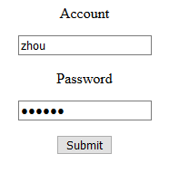

图8、在其中一个网页中输入姓名和密码

#### （3.2）要求当转移到其它页面时，这个姓名和密码将自动显示到新的网页中。



图9、显示到新的网页中

## **实验五:(可以直接访问<http://bingqiangzhou.cn:8080/Exp0105/> 查看效果)**

### （1）实验内容

设计一个密码输入的验证网页。输入界面中包括姓名、密码、重复密码、E-Mail等项。若输入完整、正确时，转向另一个网页；否则，分别显示错误信息，并汇总显示错误信息。假定密码是123456.

### （2）实验源码

#### （2.1）Default.aspx

<%@ Page Language="C#" AutoEventWireup="true" CodeBehind="Default.aspx.cs" Inherits="WebApplication4.Default" %>

<!DOCTYPE html>

<html xmlns="http://www.w3.org/1999/xhtml">

<head runat="server">

<title></title>

<style>

body{margin:auto;width:1000px;text-align:center;}

</style>

</head>

<body>

<form id="form1" runat="server" style="text-align:left;">

<p>Account</p>

<asp:TextBox ID="Account" runat="server"></asp:TextBox>

<asp:RequiredFieldValidator ID="RequiredFieldValidator1" ControlToValidate="Account"

runat="server" ErrorMessage="Account cannot be empty！" ForeColor="Red"></asp:RequiredFieldValidator>

<p>Password</p>

<asp:TextBox ID="Password1" TextMode="Password" runat="server"></asp:TextBox>

<asp:RequiredFieldValidator ID="RequiredFieldValidator2" ControlToValidate="Password1"

runat="server" ErrorMessage="Password cannot be empty！" ForeColor="Red"></asp:RequiredFieldValidator>

<p>Comfirm Password</p>

<asp:TextBox ID="Password2" TextMode="Password" runat="server"></asp:TextBox>

<asp:RequiredFieldValidator ID="RequiredFieldValidator3" ControlToValidate="Password2"

runat="server" ErrorMessage="Comfirm password cannot be empty！" ForeColor="Red"></asp:RequiredFieldValidator>

<p>E-Mail</p>

<asp:TextBox ID="Email" TextMode="Email" runat="server"></asp:TextBox>

<asp:RequiredFieldValidator ID="RequiredFieldValidator4" ControlToValidate="Email"

runat="server" ErrorMessage="Email cannot be empty！" ForeColor="Red"></asp:RequiredFieldValidator>

<p></p>

<asp:CompareValidator ID="CompareValidator1" ControlToCompare="Password1"

ControlToValidate="Password2" runat="server" ErrorMessage="Passwords are inconsistent！" ForeColor="Red"></asp:CompareValidator>

<p></p>

<asp:Button ID="Submit" runat="server" Text="Submit" OnClick="Submit_Click" />

<p></p>

<asp:ValidationSummary ID="ValidationSummary1" runat="server" ForeColor="Red"/>

</form>

</body>

</html>

#### （2.2）Default.aspx.cs

using System;

using System.Collections.Generic;

using System.Linq;

using System.Web;

using System.Web.UI;

using System.Web.UI.WebControls;

namespace WebApplication4

{

public partial class Default : System.Web.UI.Page

{

protected void Page_Load(object sender, EventArgs e)

{

}

protected void Submit_Click(object sender, EventArgs e)

{

Session["account"] = Account.Text;

Session["password"] = Password1.Text;

Session["email"] = Email.Text;

Response.Redirect("info.aspx");

}

}

}

#### （2.3）Info.aspx

<%@ Page Language="C#" AutoEventWireup="true" CodeBehind="info.aspx.cs" Inherits="WebApplication3.info" %>

<!DOCTYPE html>

<html xmlns="http://www.w3.org/1999/xhtml">

<head runat="server">

<title></title>

<style>

body{margin:auto;width:1000px;text-align:center;}

</style>

</head>

<body>

<%--<form id="form1" runat="server">

<div>

</div>

</form>--%>

</body>

</html>

#### （2.4）Info.aspx.cs

using System;

using System.Collections.Generic;

using System.Linq;

using System.Web;

using System.Web.UI;

using System.Web.UI.WebControls;

namespace WebApplication4

{

public partial class info : System.Web.UI.Page

{

protected void Page_Load(object sender, EventArgs e)

{

Response.Write("Account: " + Session["account"] + "<br>");

Response.Write("Password: " + Session["password"] + "<br>");

Response.Write("Email : " + Session["email"] + "<br>");

}

}

}

### （3）效果截图

设计一个密码输入的验证网页。输入界面中包括姓名、密码、重复密码、E-Mail等项。若输入完整、正确时，转向另一个网页；否则，分别显示错误信息，并汇总显示错误信息。假定密码是123456

#### （3.1）验证姓名、密码、重复密码、E-Mail等项，分别显示错误信息，并汇总显示错误信息

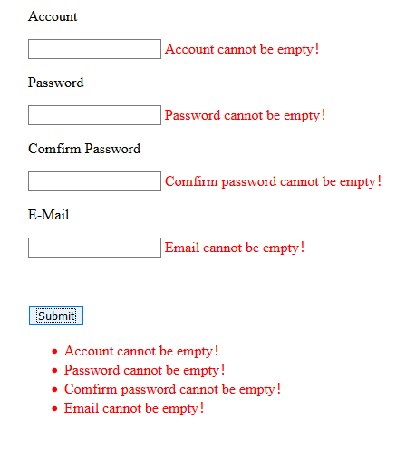

图10、验证姓名、密码、重复密码、E-Mail等项，分别显示错误信息，并汇总显示错误信息

#### （3.2）输入完整、正确时，转向另一个网页

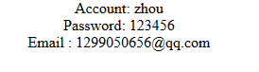

图11、输入完整、正确时，转向另一个网页